INFO2120 Revision Assignment – Andrew Bronier - 307165906

Question 1

a)
Nurse
Disease
Ward
Doctor
Patient
Supervision
Illness
Treatment
Assign
Locate

b)
SELECT D.DName, T.DStaffNo, T.AdmitNo
FROM Doctor D, Treatment T
WHERE D.DStaffNo = T.DStaffNo
AND T.DiseaseId NOT IN (SELECT E.DiseaseId
FROM Expertise E
WHERE D.DStaffNo = E.DStaffNo)

c)
SELECT W1.WardNo
FROM Ward W1
WHERE W1.Beds < (SELECT COUNT(L.AdmitNo)
FROM Locate L
WHERE W1.WardNo = L.WardNo)
d)
SELECT T.AdmitNo, COUNT(T.DStaffNo)
FROM Treatment T, Expertise E, Disease D
WHERE T.DiseaseID = D.DiseaseID
AND D.Severity = 'Deadly'
AND T.DStaffNo = E.DStaffNo
AND T.DiseaseID = E.DiseaseID
GROUP BY T.AdmitNo
e)
SELECT W.WardNo, COUNT(A.NStaffNo)
FROM Ward W, Assign A
WHERE W.WardNo = A.WardNo
AND W.Beds > (SELECT AVG(W1.Beds)
FROM Ward W1
WHERE W.Building = W1.Building
GROUP BY W.Building)
GROUP BY W.WardNo, A.NStaffNo

f)

g) C = Π (E.DiseaseId) Ơ (D.DStaffNo = E.DStaffNo) Expertise E

Π (D.Dname, T.DStaffNo, T.AdmitNo) Ơ (T.DiseaseID <-> C) Doctor X Treatment

h) CREATE VIEW Andrews_Patientcount (PatientCount) AS
SELECT count(L.AdmitNo)
FROM Locate L
WHERE L.WardNo = Ward.WardNo
AND W.Building = 15

GRANT SELECT on Andrews_Patientcount TO Andrews

Question 2

a) The columns of A, C and D are not a candidate key since they don’t produce all of the value of the relation, F is missing.
b) A candidate key suitable for the relation is (ABCF) as these columns will give DEG that are to the right hand side of the constraints. ( F -> F in addition to current constraints)

c) Rel1 is not in BCNF since a super key does not exist and the dependencies of the constraints on the left hand side do not form the total relation specified by the schema.
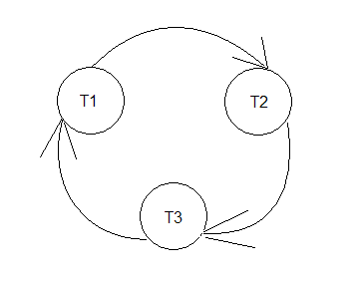
d)

Question 3

a)
b) Serializable refers to the consistency that the interleaved transactions has, it is serializable if one transaction has performed its operations on a certain row/data item and committed them before another transaction can either read or write from that same row/data item, ensuring the data is accurate and up to date.
c) SL(b) r1(B) XL(B) w1(B) SL(A) r3(A) * SL(B) r3(B) SL(B) r2(B) SL(C) r2(C) XL(C) w2(C) SL(C) r3(C) XL(C) w3(C) SL(C) r1(C) XL(A) w1(A)

- This is the position where the schedule will be blocked and will have to wait until the lock is removed, T1 holds an exclusive lock to B in order to write.

Question 4

a) Each row is 80 bytes (40 + 24 + 16)
Rel1 has 100,000 row = 8,000,000 bytes in total

Each block can hold 4000 useable bytes
8,000,000 / 4,000 = 2000 blocks needed

b) 2 records

